# CEEB File Processing Instructions

Every month we receive a CEEB file that contains updates to schools in the EligibilityCenter database. In this file, there may be new schools ("A" records), updates to existing schools ("U" records), or schools that have been deleted ("D" records).

Ultimately this process was intended to be automated, but at this time it is performed manually. To load the files…

* 1. Copy the CEEB file received from the NAIA to your local machine. Will be named in the format "YYYY-YYYY CEEB List Update MM-DD-YYYY.txt”. Keep the existing mapping if you are prompted.
  2. The file must first be staged into the **EligibilityCenter** database. To do this, in Visual Studio open the **NAIA.EC.ETL** solution and edit the **StagePlayNAIA** package.
  3. In that package, edit the **Flat File Connection Manager CEEB Secondary** connection updating the file name to be the name of the recent file received. Make sure the database connections are pointed at the production environment.
  4. Ensure that the **Truncate CEEB Staging Tables** and **Stage CEEB Secondary** steps in the control flow are the only ones *enabled*. Should look like this…

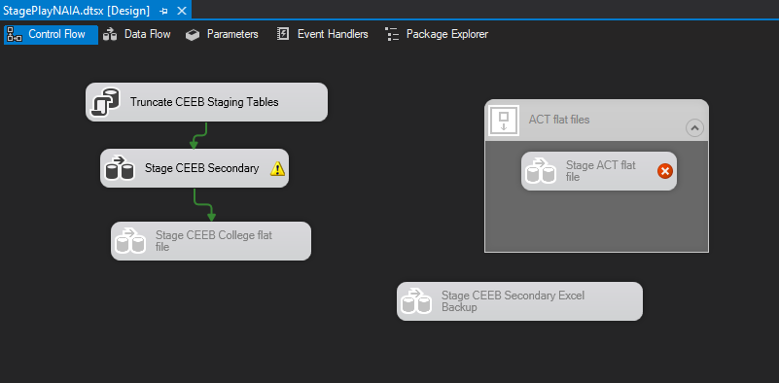

* 1. Execute the **StagePlayNAIA** package to populate the table **stage.CEEBSecondary** table. In that table you will see a column called **change_cd** that will contain the codes "A", "U", or "D" that represents if the schools is an add, update, or delete respectively.
  2. At this point we need to notify the NAIA of the schools that are NOT currently in the EligibilityCenter database that would be added by this file. The NAIA wants to manually approve the adding of any new school. As a result, we need to provide them with a list of these schools to approve. To do so, run the following query against the production database…

select CEEB_no,address_line1_txt,address_line2_txt,change_dt,change_cd,school_type_cd,School_nm,

DomesticAndForeignAddress_txt,Address_ind,Approved_ind

from stage.CEEBSecondary c

where not exists (select * from schools s where c.CEEB_no = s.ceeb_no)

Provide the output of this query via the DevOps support ticket created for this CEEB update.

* 1. The NAIA will give you a list of the new schools they want to add. Once you have that list of CEEB's, run the following update statement…

update stage.CEEBSecondary

set Approved_ind = 'true'

where CEEB_no in ([list from NAIA here])

* 1. We must now update a configuration setting in the database that indicates that the process is ready to run. To do this, run the following update statement…

update dbo.ListItemContent

set custom_value2_txt = 'Y'

where list_id = (select id from List where list_nm = 'Last Run Dates')

and value_txt = 'CEEB File Upload'

* 1. At this point we are ready to run the ETL process. In Visual Studio, open the package **PlayNAIA** in the **NAIA.EC.ETL** solution. Edit the control flow (if necessary) to disable the **Populate Schools College** data flow step.   
       
     Make sure your connections are pointing at the production environment.  
       
     It should look like this…

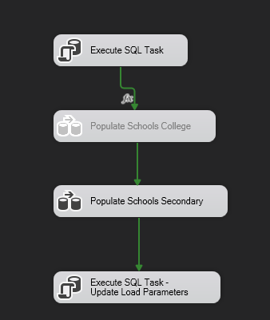

* 1. Execute this package. Once complete confirm that all the new schools have been added to the Schools table.